# The Plugin Steps Viewer

When working in environments consisting of many solutions with many plugins, it’s often difficult to get a fair understanding about registered plugin assemblies, types and steps. You can display this information in the Plugin Registration Viewer, but the tool is slow, and you cannot filter on any criteria. As I had a need to do exactly this, I created a standalone tool to display the registered plugin steps in a flat list with some filtering options. I then decided to turn it into a plugin for the XrmToolBox. This first release v0.6.0 does not include everything you might expect. But it does give you a very fast overview about the registered steps in your environment.

The tool consists of three panes:

* The list of plugin steps (green area)
* The filters (orange)
* The properties (blue)

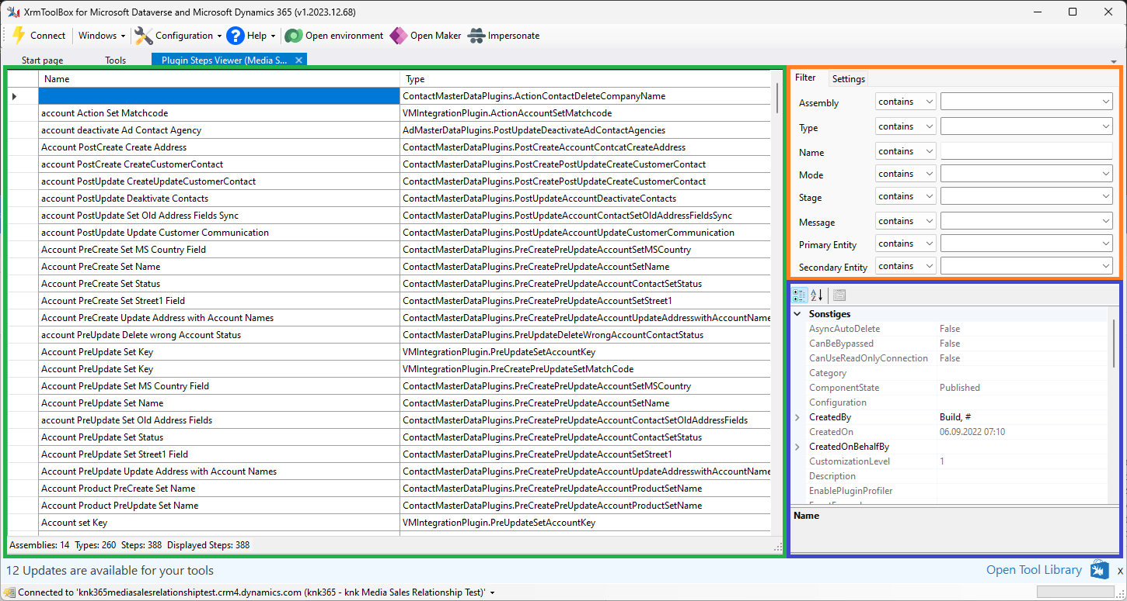

## The plugin steps

Obviously, this is the list of registered plugin steps. Assemblies from Microsoft are excluded by default. You can include them if required, but the initial loading time will be much higher if you do so.

Ein Bild, das Text, Screenshot, Zahl, Reihe enthält.

The list contains 9 columns:

1. The plugin step name (Name)
2. The plugin type name, including its namespace (Type)
3. The assembly’s name, without the dll extension (Assembly)
4. The execution mode (Mode)
5. The execution stage (Stage)
6. The message, either predefined or custom (Message)
7. The execution rank (Rank)
8. The primary entity logical name (Primary Entity)
9. The secondary entity logical name (Secondary Entity)

After the list is built, the columns are automatically resized to fit the contents. You will need a wide screen monitor to see everything, but you can reorder and resize columns if the initial layout doesn’t fit your needs.

## The filters

The filters let you filter the plugin steps. Each filter has an operator where you can select “contains”, “begins with” or “is”. The following will display only plugin steps registered for the account entity and running asynchronously:

Ein Bild, das Text, Screenshot, Zahl, Schrift enthält.

It should be very clear what these filters are doing. These filters are saved and will be used as the default when you connect to this environment again.

The Settings tab contains the list of excluded assemblies. Any assembly starting with one of these names will not be included in the displayed steps. And most importantly, its types and steps won’t be retrieved.

Ein Bild, das Text, Screenshot, Schrift, Software enthält.

You can change it to whatever you want and hit the  button to reload the plugin steps. If you clear the entire list, this will take some time. Be sure to try it once and then revert it to the prior stage 😉.

The  button reloads the last saved exclusion list and  will save it. This is a system-wide setting and affects all connections. To restore the default list at any time, simply click .

## The properties

For performance reasons and to give you the most important information, the list only contains the above-mentioned properties. To get all information, simply select a step. It will populate the property grid so that you can see any data not displayed in the list.

# Comments welcome

This is my first plugin for the XrmToolBox and I hope to have done the most important parts correctly. The entire code is hosted on GitHub, where you can create issues and comments. There is plenty of room for improvements, but this first release should be good enough to assist in its current state.